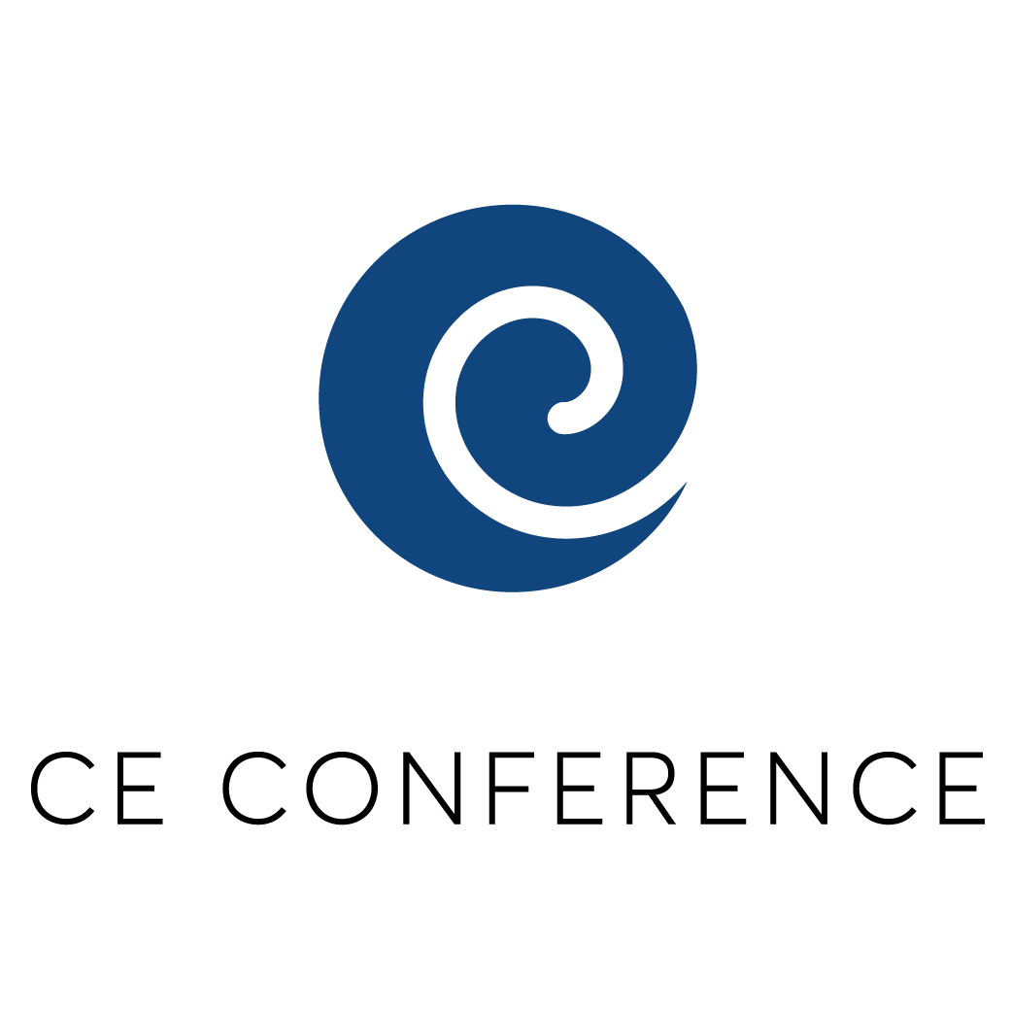
Hack to London!

A programme organised by the University of London Czech & Slovak Society

Thank you for your interest in the 2018 Hack to London Programme.

The Hack to London is an extension of the CE Conference Project organised annually by the University of London Czech & Slovak Society (ULU CZSK Society), an organisation which brings together Czech and Slovak students of prestigious universities in London in professional and social events. The First CE Conference took place in March 2017 and was a great success, with keynote speeches and panel discussions featuring some of the most prominent Czech and Slovak figures and with an attendance of over 250 students and young professionals. However, realising that attendance of such events is limited to London-based students and professionals and feeling a necessity to extend such opportunities beyond the British borders to our counterparts back in Czech Republic and Slovakia, this year we have decided to launch a unique Hack to London programme.

The Programme aims to invite a number of outstanding Czech and Slovak high school students to spend four days in London in March 2018. The full cost of the trip for each student, including the cost of accommodation and return flight tickets, will be covered by the ULU CZSK Society. The goal of this project is to increase awareness among high school students from Czech Republic and Slovakia on pursuing a university degree in the UK as well as to connect these students with the London Czech & Slovak community, which may be of benefit to them in both professional and personal development.

The programme will occur March 8 – 11, 2018, with the participants arriving to London on Thursday evening and leaving on Sunday. All applicants will follow a four-day programme which will feature the attendance of the Second Annual CE Conference at LSE on Saturday, the attendance of speakers and sponsors dinner on Friday evening, as well as an opportunity to participate in speed-dating with London-based Czech and Slovak students based on the applicants’ preference for a course of study. Cultural programme will also include sightseeing and touring of London.

The participants of the programme will be selected by an Advisory Board based on their motivation, academic performance and socio-economic background. The results of the selection process will be released in the second half of February and individual applicants will be informed about the outcome of their application via e-mail.

Participants of the programme should:
- Have a strong academic potential and desire to learn
- Be open to experiencing new cultures and ways of thinking
- Show a commitment to volunteering work and social initiatives in their home communities
- Have an energetic and positive attitude and demonstrate a willingness to expand his or her horizons

What to expect during the programme:
- Attendance at the Second Annual CE Conference at LSE with workshops and panel discussions
  - Topics include: Roma inclusion; Future of automobile industry & the role of innovation; Social bubbles and divided society; Financial future of the CE region
- Attendance at the Speakers and Partners Dinner with an opportunity to network with important figures from Czech Republic and Slovakia
- Speed-dating with London-based Czech and Slovak students based on the applicant’s expressed course of study
- Sightseeing and touring of London

What is covered?
There is no application fee for applicants.

The ULU CZSK Society, in conjunction with its private partners and sponsors, will pay for transportation to and from the participants’ home countries and the United Kingdom. Other programme costs including site visits, ground transportation, accommodation and meals will also be covered by the programme. Travel insurance for participants will also be covered.

Participants are responsible for expenses related to the transportation to and from the airport at their respective countries of residence and for spending money for souvenirs and other items in the UK.

Who is eligible to apply?
Student applicants must:
- Be at least 16 years old at the time of the programme;
- Be in a second or third year of high school at the time of the programme;
- Have permission from either a parent or legal guardian to participate in the programme;
- Have citizenship and current residency in the country which you are applying for (Czech Republic or Slovakia);
- Be proficient in English; and
- Submit a complete application by the given deadline.

What are the criteria for selection?
Students will be evaluated on the following characteristics:
- Proven track record of participating in community activities
- Demonstrated leadership skills and interest in issues in their countries
- Outstanding academic performance and a desire to learn
- English proficiency
- Socio-economic background

APPLICATION FORM

Applications should be e-mailed to: sk.cz.society@gmail.com
In the subject line of the e-mail please write: HACK TO LONDON

If you are not able to scan and e-mail your application, you may also send it via post mail to the following address:

Kristina Durcakova
38 Newland Court
Bath Street
EC1V 9NS
London
United Kingdom

APPLICATION DEADLINE: The final deadline is 12 February 2018.

To complete your application please submit the following information:
- Student Background Information
- Hackathon – Idea for a Solution to a Community Problem
- Long Essay
- Parent/Guardian Information

Please answer all questions in English. Make sure that your name is written on ALL pages of your application.

The final submission e-mail should feature three separate documents: Completed Application Form; Part II (Hackathon) in a separate file; and Part III (Long Essay) in a separate document.

PART I: STUDENT BACKGROUND INFORMATION

Student Information

Name ______________________________________________________________________
last first

Permanent address _________________________________________________________

Permanent telephone _________________________________________________________

Email _________________________________________________________

Date of birth (dd/mm/yy) _______________ Age ___________ ____ male ____ female

Place of birth __________________________ Country of citizenship __________________
city and country

Where did you first hear about the programme? (Please be as specific as possible).

School Information

School you currently attend ________________________________ School year _________

Expected graduation date ________________________________

School address ________________________________________________________________

________________________________________________________________

Languages

What is your native language (mother tongue)? ___________________

How many years of English study have you had? ___________________

How would you describe your English skills? Spoken: Excellent Good Adequate Poor
(circle the answer) Written: Excellent Good Adequate Poor

Travel Background

Have you ever lived and/or studied outside of your home country, even if only for a short time?
Yes/No

If yes, please provide a brief description including dates and location.

______________________________________________________________________________

______________________________________________________________________________

______________________________________________________________________________

______________________________________________________________________________

Have you ever travelled by plane?
Yes/No

If yes, please provide details of your most recent trips:

Month and Year of the Travel | Duration of Stay | Destination (City and Country) | Purpose of the travel (e.g. family holiday, exchange program, competition)

Activities

Please list all extracurricular activities you currently take part in (school clubs, sports teams, youth organisations, community service activities, leisure time activities).

Activity | Number of years participated in | Number of hours per week

PART II: HACKATHON - IDEA FOR A SOLUTION TO A COMMUNITY PROBLEM

Your task in this part of application is to identify the most pressing issue in your community (e.g. youth unemployment, illiteracy, poverty, environmental issues, etc.) and come up with an idea for addressing this issue.

The community problem and your solution to it can be presented in a variety of ways, using technology when necessary. For example, you can present your ideas through a website, an application, a video recording or a short essay answer. There is no limit to your creativity.

This part of the application allows for the free use of creative problem solving for those who do not show aptitude for essay-writing or do not consider themselves strong essay writers. The selection procedure will not, therefore, bias against those who decide to present their community problem and a solution to it through a short essay answer.

You should send your answer to this part of the application separately from the main application form (i.e. if you are writing a short essay, submit it in a separate document; if you are creating a website, attach a link to the final e-mail, etc.).

PART III: LONG ESSAY

In a separate document, please write a motivation letter. The letter should include your journey so far, your motivation to participate in this programme and how it would benefit you, as well as your plans for the future. Please write the motivation letter in clear English and on computer.

Although we will be evaluating your English skills, we are most interested in the content of the letter. (700 word maximum per essay).

PART IV: INFORMATION ON PARENTS OR GUARDIANS

Parent/Guardian 1

Name __________________________________________________________________________
last first relation to you

Address ________________________________________________________________________

Telephone/E-mail ________________________________________________________________

Parent/Guardian 2

Name __________________________________________________________________________
last first relation to you

Address ________________________________________________________________________

Telephone/E-mail ________________________________________________________________

Other Family Members

Parent/Guardian and Participant Approval (signed and scanned for sending by e-mail)

My son or daughter has my permission to apply for the Hack to London programme, conducted by the University of London Czech and Slovak Society, and to participate in the full programme if accepted. At the same time, I take into consideration that none of the people in the receiving country take responsibility for a minor. However, students will be under permanent supervision of the LSESU Czech and Slovak Society coordinators and they will have a full travel insurance, which the society will cover for them.
Môj syn alebo dcéra má moje povolenie prihlásiť sa do programu Hack to London, ktorý je organizovaný University of London Czech and Slovak Society, a zúčastniť sa na plnom programe, ak bude prijatý/á. Zároveň beriem na vedomie, že žiadna z osôb v prijímajúcej krajine nepreberá zodpovednosť za máloleté dieťa. Študenti však budú pod neustálym dozorom koordinátorov z LSESU Czech and Slovak Society a bude im hradené plné cestovné poistenie.

Parent/Guardian Signature Date
Podpis rodiča/zákonného zástupcu Dátum

I agree that all of the information in this application is true and I agree that if chosen to participate, I will participate in all programme activities in the United Kingdom.

Applicant Signature Date

